DIS-INDO-Maluccas-Leti Islands

The **Leti Islands** of Indonesia are part of the Maluccas or Maluku Islands, in southwest Maluku Province.

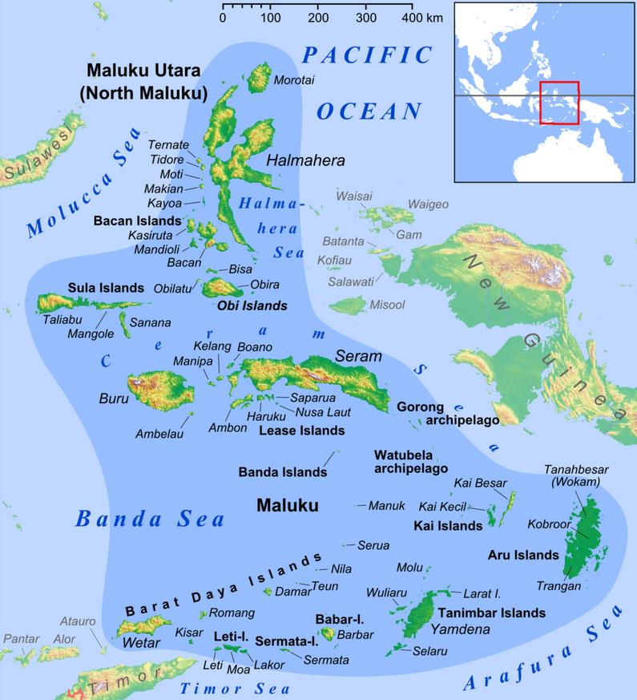 The main islands are Moa, Leti and Lakor or 750 square kilometres (290 sq mi) in area with cultivation of rice, coconut palms and tobacco, animal husbandry, and fishing as main endeavors. Leti, the westernmost island, has a population of 7,526. The island is a triangular mountain ridge, subtended by Koli Besar mountain in the east and the Rapat mountains in the west.

The earliest archaeological evidence of human occupation of the region is about thirty-two thousand years old, but evidence of even older settlements in Australia may mean that Maluku Islands had earlier long-distance immigrants. Trading with and occupation of many Maluku Islands s probably began about 22,000-17,000 B.P.

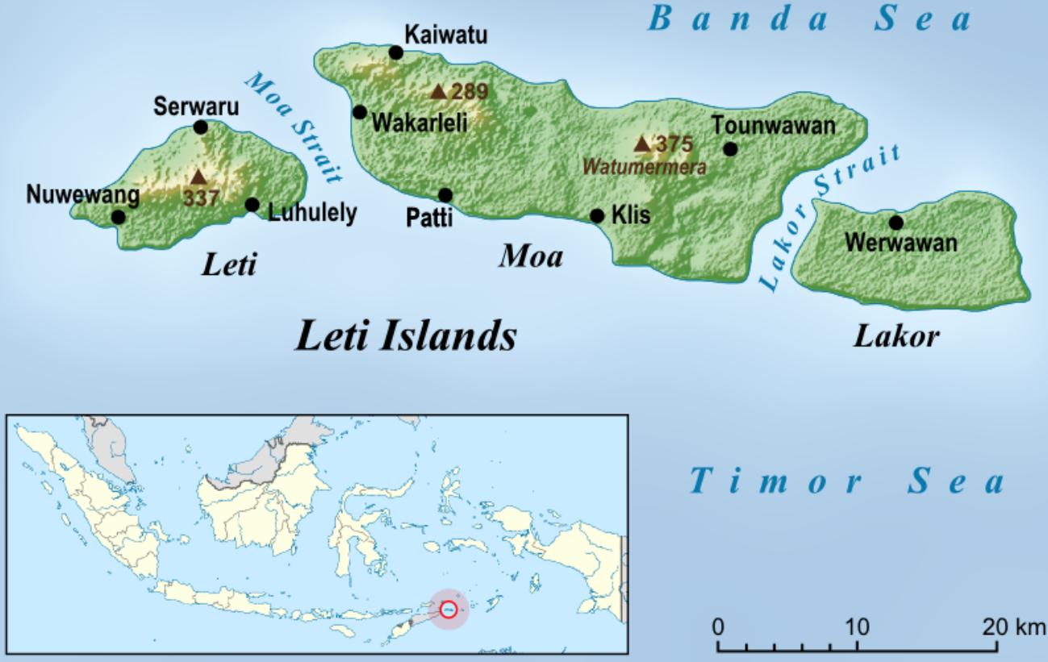

Map of Leti Islands by [Uwe Dedering](https://commons.wikimedia.org/wiki/User:Uwe_Dedering), https://upload.wikimedia.org/wikipedia/commons/thumb/5/5f/Leti_Islands_en.png/800px-Leti_Islands_en.png

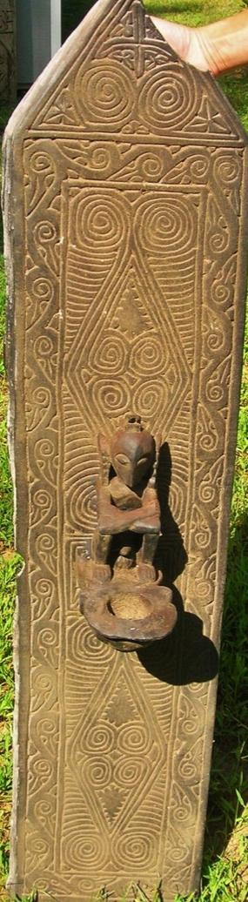 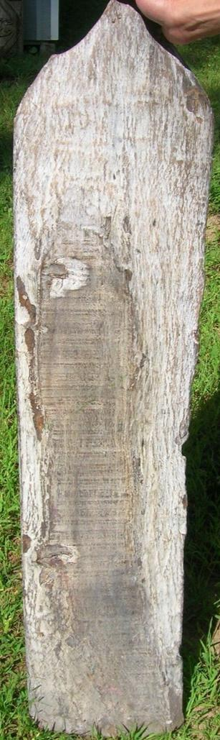

Nusa Tenggara. Antiquities. Image from Leti - Opo-lero. Wooden, 52 cm. high (20.5"). Collection: Tropical Museum, Amsterdam. Photo: Museum, 1468/167a.

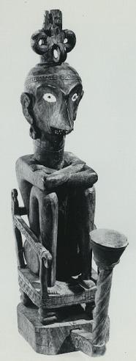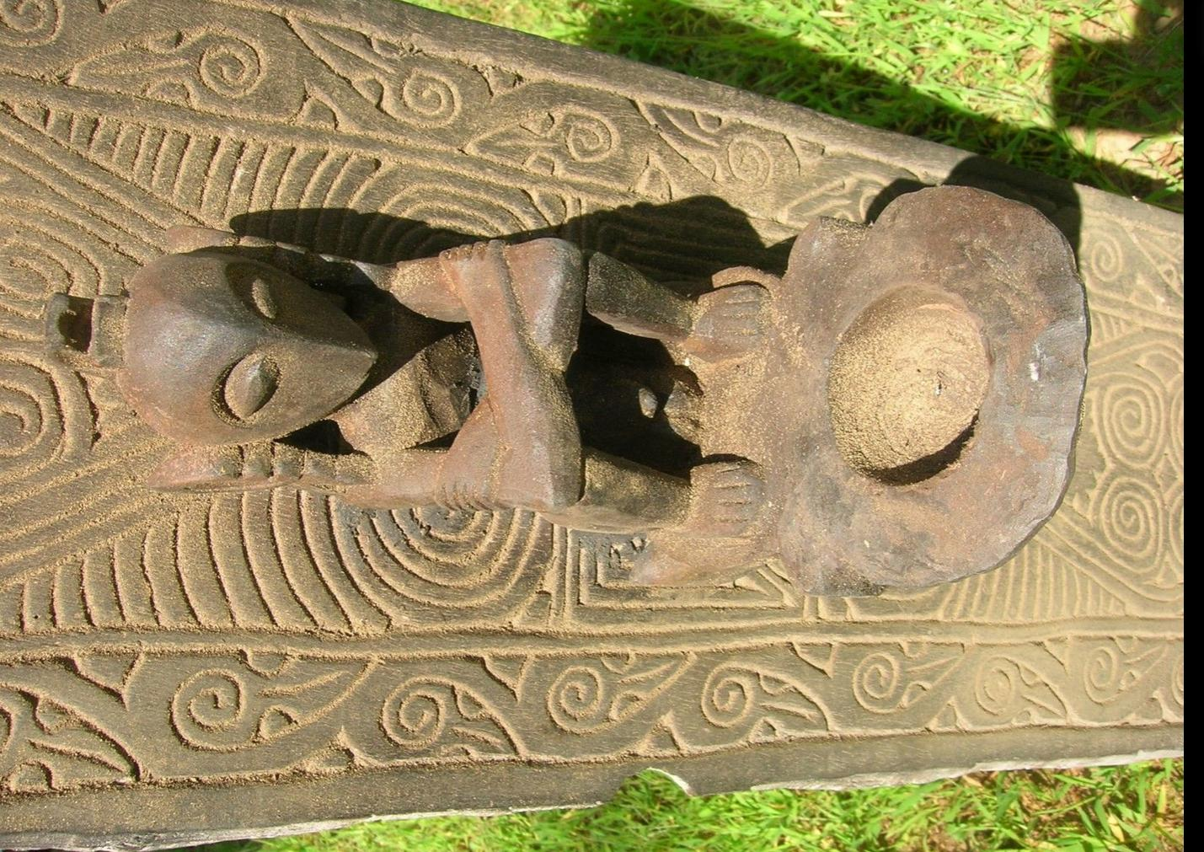

# Left: Nusa Tenggara. Antiquities. Image from Leti - Opo-lero. Wooden, 52 cm. high (20.5"). Collection: Tropical Museum, Amsterdam. Photo: Museum, 1468/167a. Right: Leti - Opo-lero. Wooden Ritual Altar, Ex Bouck Estate, New York City, 2014.

Sold by [primitifstuff](http://myworld.ebay.com/primitifstuff) ( [1790](http://feedback.ebay.com/ws/eBayISAPI.dll?ViewFeedback&userid=primitifstuff) )

### Delivery package 1 of 1

Estimated delivery Friday, Oct 9, 2015 - Tuesday, Oct 13, 2015

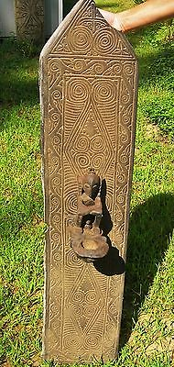

#### [sale orig $199-LETI RITUAL ALTAR 40"](http://www.ebay.com/itm/221899937089)

|  |  |
| --- | --- |
| Item price | $89.99 |
| Quantity | 1 |
| Item number | 221899937089 |
| Shipping service | USPS Priority Mail |